**Exercise 1: Configuring a Basic Spring Application**

1. **Configure the Application Context:**

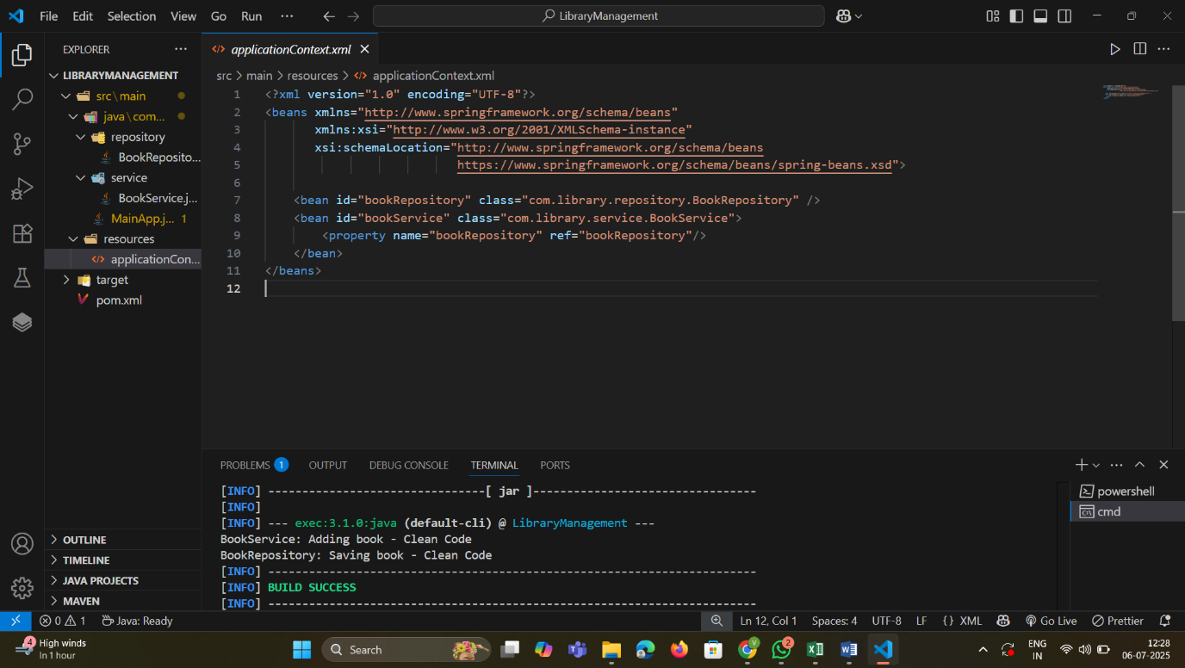

**2. Define Service and Repository Classes:**

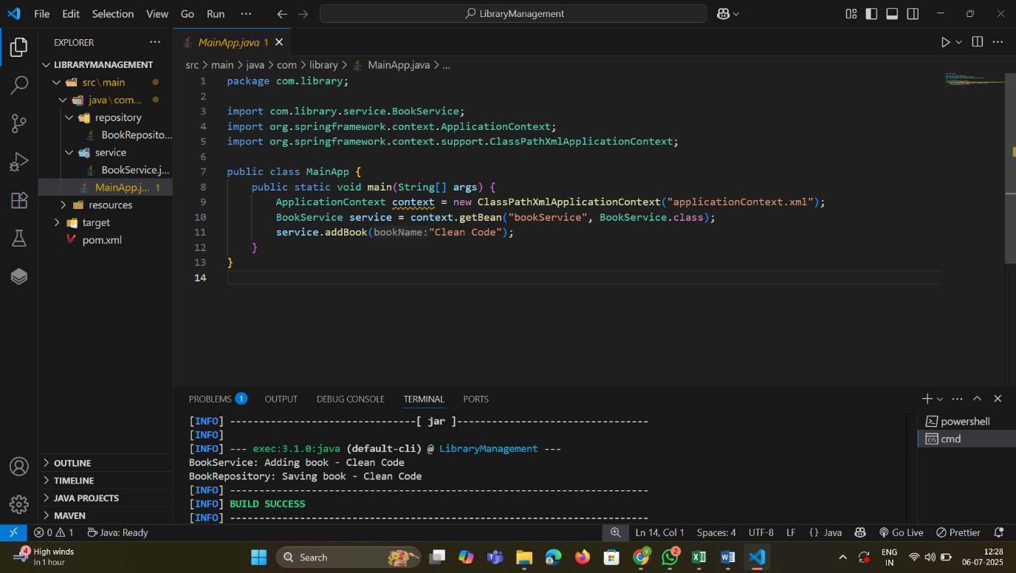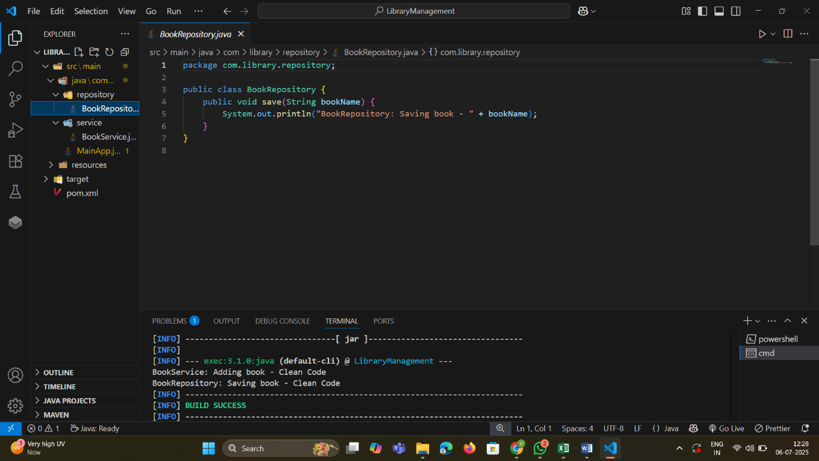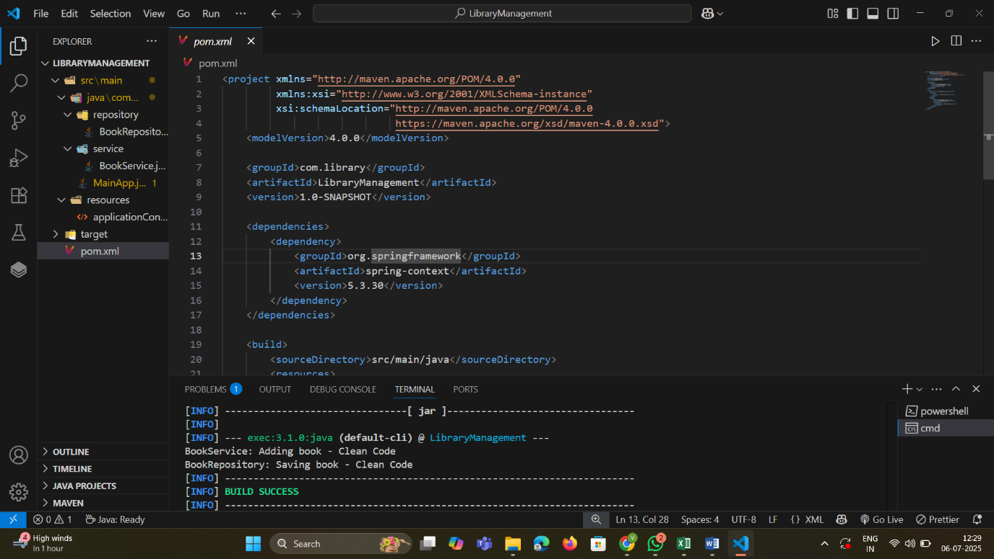

**Exercise 2: Implementing Dependency Injection**

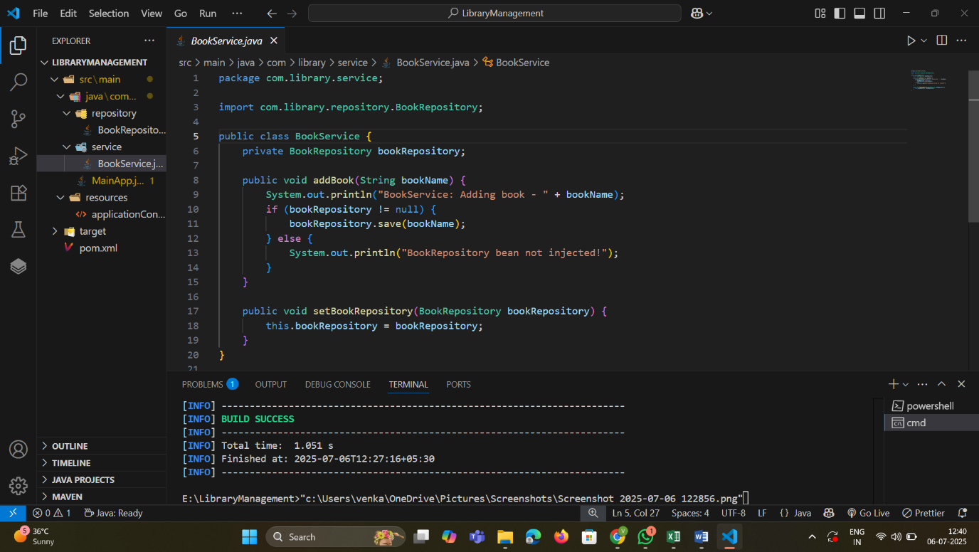

->Through setter based dependency injection ,bookRepository dependency is injected to BookService class.

**Exercise 4: Creating and Configuring a Maven Project**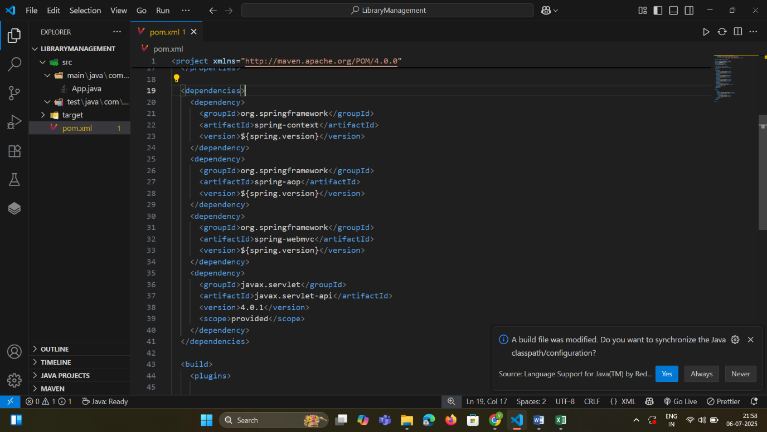

* + ->Included dependencies for Spring Context, Spring AOP, and Spring WebMVC.

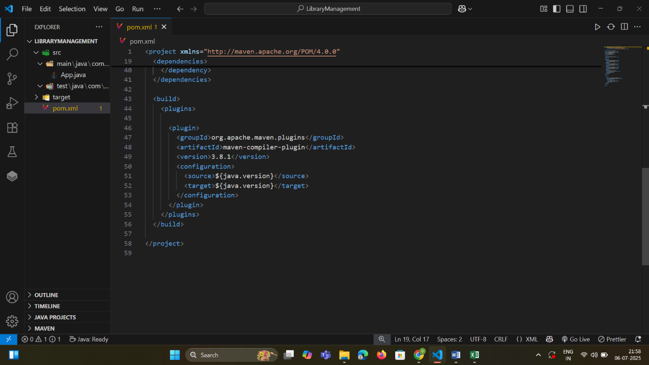

* + ->Configured the Maven Compiler Plugin for Java version 1.8 in the pom.xml file.

**Exercise 5: Configuring the Spring IoC Container**

1. **Update the BookService Class**
2. 
3. **Run the Application:**

